JOUR 4251
9.1 Persuasion and attitude change (chapter 5 - part 2*)
*Watch recap video for Ch. 5 part 1
Models that explain persuasion effects

Yale reinforcement approach
McGuire’s Model of Persuasion
Cognitive Response Model
Dual Process Theories Unimodel
ELM - Elaboration Likelihood Model HSM - Heuristic Systematic Model
Central Route / systematic
processing
Peripheral Route / heuristic processing
Arguments Heuristic
Stable attitude change
Temporary attitude change
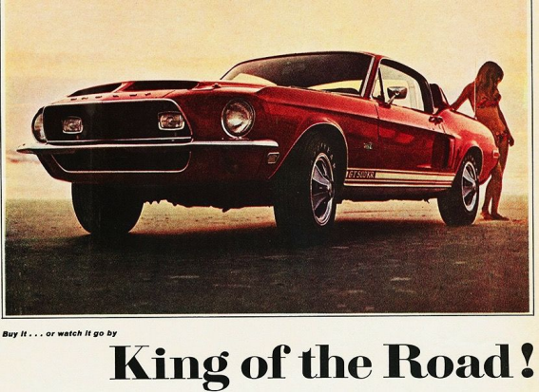
Central Route / systematic
processing
Peripheral Route / heuristic processing
Arguments Heuristic
Stable attitude change
Temporary attitude change
Three differences between the routes:
1. Amount of cognitive effort to process a message 2. Type of information used to draw conclusions 3. The results
Dual process theories
Ability
Yes
Two questions:
1. Are you able to process it?
a. Not distracted, not tired, have the correct knowledge etc.
2. Are you motivated to process it? a. Do you care? Is it relevant to you?
No
Motivation
Yes
Central Route / systematic
processing
No
Peripheral Route /
heuristic processing

In sum
Dual process theories
Persuasion depends on how a message is processed (systematic/heuristic processing), which depends on both ability and motivation to process a message.
Unimodel
Persuasion is a singular process of drawing conclusions from available evidence.
What’s next?
● Menti questions (9.1) available on Canvas
○ Not mandatory, not graded. Just for you to get feedback!
● Start reading chapter #6
○ Reading response #7 on this chapter is due Thursday, March 26 ○ See FAQ for new assignment regulations

